
Ain Shams University - Faculty of Engineering I-CHEP
CSE382 (UG2023) - Introduction to Machine Learning
Phase 1

May 2, 2026
Submitted to
Dr. Hossam El-Din Hassan
Eng. Ali Ahmed Ali Ahmed

Submitted by:
- 23P0303 : Ahmed Mohamed Fahmy Eldawy
- 2301128 : Hady Mostafa Abdelaziz Mohamed
- 23P0266 : John George Mikhael Khalil
- 23P0043 : Mohamed wael ahmed ahmed
- 23P0192 : Peter Maged shokry Noshy

Table of Contents
1.0 Introduction 2
2.0 Preprocessing 2
3.0 Models 2
3.1 K-Nearest Neighbors 2
Mathematical Formulas 2
Results 3
3.2 Logistic Regression 3
Mathematical Formulas 3
Results 5
3.3 Naive Bayes 5
Mathematical Formulas 5
Results 6

GitHub : https://github.com/Ahmed-Fahmy00/Mnist-Classification

Introduction
This report presents the implementation and evaluation of three machine learning algorithms K Nearest Neighbors (KNN), Logistic Regression, and Naive Bayes for binary image classification on the MNIST handwritten digit dataset, as part of Phase 1 of the Project. Each model is built from scratch and evaluated using accuracy, precision, recall, F1-score, and confusion matrices.

Preprocessing
Normalization: Raw MNIST pixel values in [0,255] are normalized to [0,1]: x = x/255
Class Imbalance: Random undersampling is applied to the training split only
N_{balanced} = min(|C0|,|C1|)
Feature Extraction: Three image representations were evaluated. Flatten converts each 28 × 28 image into a one-dimensional feature vector $x∈R^{784}$. PCA (Principal Component Analysis) projects the data onto the top principal components while retaining 95% of the total variance, with the transformation fitted using only the training set. HOG (Histogram of Oriented Gradients) extracts gradient-based features using 4 × 4 pixel cells, 2 × 2 block normalization, and 9 orientation bins.
Train, Validation, Test Splits: The dataset was divided into three subsets: 60% for training, 20% for validation, and 20% for testing. The training set was used to fit the model, the validation set was used for hyperparameter tuning and model selection, and the test set was reserved for final performance evaluation on unseen data.

Models

K-Nearest Neighbors
KNN is a non-parametric, instance-based classifier with no explicit training phase the dataset is memorized, and all computation occurs at prediction time. Given a query sample, KNN computes its distance to every training point, selects the K closest neighbors, and assigns the majority class label. K is tuned via 5-fold cross-validation over K ∈ {1,3,5,7,9,11}
Mathematical Formulas
- Euclidean Distance (Vectorized): Given query matrix X_{q} (ℓ × d) and training matrix X_{tr} (m × d), squared distances are computed via a single matrix multiplication
$$D^{2}={\left\|X_{q}\right\|}^{2}+{\left\|X_{tr}\right\|}^{2}-2X_{q}X_{tr}^{⊤}$$

- Majority Vote (Classification Rule): The predicted class is the most frequent label among the K neighbors $\hat{y}=\arg{\max_{c}\left|\{x_{i}∈N_{K}\left(x\right):y_{i}=c\}\right|}$
- Class Frequency Ratio (Probability Estimation): Soft probabilities are the fraction of the K neighbors belonging to each class
$$\hat{P}\left(y=\left.c\right|x\right)=\frac{count_{c}}{k}$$
Results for class (1, 0)
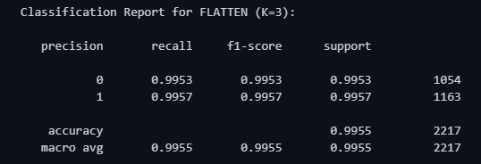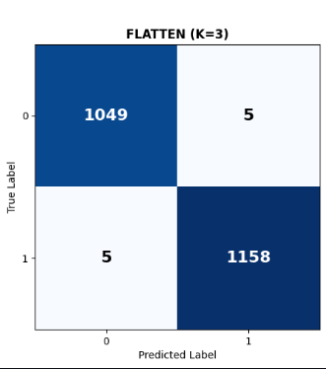

Logistic Regression
Linear, probabilistic classifier that learns weights during training. Given a sample, it computes a linear score, applies the sigmoid function to produce a probability, and assigns a class using a threshold. The model is trained using binary cross-entropy and gradient-based optimization.
Mathematical Formulas
- Sigmoid Activation:
The predicted probability is computed via the sigmoid function
$$\hat{y}=σ\left(z\right)=\frac{1}{1+e^{-z}} \left(B×1\right)$$
Applied element wise, $\hat{y_{i}}$∈ (0,1) is the predicted probability that sample i belongs to digit d
- Loss Function (Binary Cross-Entropy):
For a mini-batch of size B:
$$L\left(w\right)=-\frac{1}{B}\sum_{i=1}^{B}{\left[y_{i}log\left(\hat{y_{i}}\right)+\left(1-y_{i}\right)log\left(1-\hat{y_{i}}\right)\right]}$$
The validation loss uses N_{val} = 10,000 samples and is computed after each full epoch to monitor generalization.
- Handling Class Imbalance
To account for an imbalanced class distribution in the training data, class-specific weights are introduced into the loss function. Given N total samples, n_{pos} positive examples, and n_{neg} negative examples, the weights are:
$$w_{pos}=\frac{N}{2n_{pos}}, w_{neg}=\frac{N}{2n_{neg}}$$
These factors up weight the minority class and down weight the majority class, ensuring balanced gradient signals. The weighted binary cross-entropy loss becomes:
$$L\left(w\right)=-\frac{1}{B}\sum_{i=1}^{B}{\left[w_{pos}y_{i}\log\left(\hat{y_{i}}\right)+w_{neg}\left(1-y_{i}\right)\log\left(1-\hat{y_{i}}\right)\right]}$$

- Gradient Derivation via Chain Rule
Why $\frac{∂L}{∂w}=\frac{1}{B}X_{b}^{⊤}\left(\hat{y}-y\right)$
We derive the gradient from first principles using the chain rule through three composed functions.
Step 1 Loss w.r.t. ${\hat{y}}_{i}$
$$\frac{∂L}{∂{\hat{y}}_{i}}=-\frac{1}{B}\left(\frac{y_{i}}{{\hat{y}}_{i}}-\frac{1-y_{i}}{1-{\hat{y}}_{i}}\right)=-\frac{1}{B}⋅\frac{y_{i}-{\hat{y}}_{i}}{{\hat{y}}_{i}\left(1-{\hat{y}}_{i}\right)}$$
Step 2 ${\hat{y}}_{i}$ w.r.t. $z_{i}$ (sigmoid derivative)
$$\frac{∂{\hat{y}}_{i}}{∂z_{i}}=σ\left(z_{i}\right)\left(1-σ\left(z_{i}\right)\right)={\hat{y}}_{i}\left(1-{\hat{y}}_{i}\right)$$
Proof. Let $σ={\left(1+e^{-z}\right)}^{-1}$:
$$\frac{dσ}{dz}=\frac{e^{-z}}{{\left(1+e^{-z}\right)}^{2}}=\frac{1}{1+e^{-z}}⋅\frac{e^{-z}}{1+e^{-z}}=σ⋅\left(1-σ\right)$$
Step 3 $z_{i}$ w.r.t. $w$
$$\frac{∂z_{i}}{∂w}=x_{i}' \left(785×1\right)$$
Chaining Steps 1–3
$$\frac{∂L}{∂w}=\sum_{i=1}^{B}{\underset{\text{Step 1}}{\underset{⏟}{\frac{∂L}{∂{\hat{y}}_{i}}}}}⋅\underset{\text{Step 2}}{\underset{⏟}{\frac{∂{\hat{y}}_{i}}{∂z_{i}}}}⋅\underset{\text{Step 3}}{\underset{⏟}{\frac{∂z_{i}}{∂w}}}$$
Substituting:
$$\frac{∂L}{∂w}=\sum_{i=1}^{B}{\left(-\frac{1}{B}⋅\frac{y_{i}-{\hat{y}}_{i}}{{\hat{y}}_{i}\left(1-{\hat{y}}_{i}\right)}\right)}⋅{\hat{y}}_{i}\left(1-{\hat{y}}_{i}\right)⋅x_{i}'$$
The ${\hat{y}}_{i}\left(1-{\hat{y}}_{i}\right)$ terms cancel exactly:
$$\frac{∂L}{∂w}=\frac{1}{B}\sum_{i=1}^{B}{\left({\hat{y}}_{i}-y_{i}\right)} x_{i}'$$
Writing this as a matrix product:
$$\frac{∂L}{∂w}=\frac{1}{B} X_{b}^{⊤}\left(\hat{y}-y\right) \underset{X_{b}^{⊤}}{\underset{⏟}{\left(785×B\right)}}⋅\underset{\left(\hat{y}-y\right)}{\underset{⏟}{\left(B×1\right)}}=\underset{∇w}{\underset{⏟}{\left(785×1\right)}}$$
This matches de_dw = np.dot(xi_batch.T, error) / batch_size exactly, where error = y_hat - y.
- Weight Update Rule
$w←w-η⋅\frac{∂L}{∂w}$ (785×1)
Matching w -= learning_rate*de_dw, where η is learning_rate.
- Mini-Batch Training
Each epoch proceeds as follows:
- Shuffle: draw a random permutation of the 50,000 training indices indices = np.random.permutation(
- Batch loop: for batch k = 0,1,...,⌊N/B⌋ − 1:
start = k · B, end = start + B
Extract X_{b} = X_{shuffled} [start : end] (B×785) and y_{b} (B×1), then perform the forward pass and weight update described above.

Results for Class 5
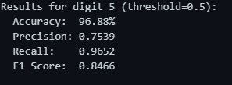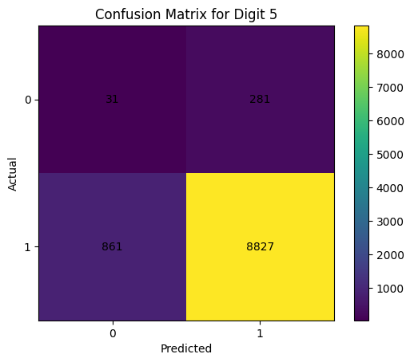

Naive Bayes
probabilistic classifier with a fast-training phase that computes class priors and feature statistics. It assumes feature independence and models each feature with a Gaussian distribution. Given a sample, it computes class probabilities and selects the most likely label.
Mathematical Formulas
- Posterior Maximization: The classifier predicts the class by maximizing the posterior probability using Bayes theorem
$$P\left(y | x\right)∝P\left(y\right)\prod_{i}{P\left(x_{i} | y\right)}$$
- Log Probability Form: prevent numerical underflow, logarithms are used
$$\hat{y}=\arg{\max_{c}\left(\ln{P\left(y=c\right)}+\sum_{i}{\ln{P\left(x_{i} | y=c\right)}}\right)}$$
- Gaussian Likelihood: Each feature (pixel) is modeled using a Gaussian distribution
$$P\left(x_{i} | y=c\right)=\frac{1}{\sqrt{2πσ^{2}}}\exp\left(-\frac{{\left(x_{i}-μ\right)}^{2}}{2σ^{2}}\right)$$

Results for class (1, 0)
